**Practical - 1**

**Aim: Write a JavaScript program to apply validation on various fields of student registration form and validate it on validator.w3.org**

**Code:**

**form.html:**

<!DOCTYPE html>

<html lang="en">

<head>

    <title>

        Form

    </title>

    <style>

        input::-webkit-outer-spin-button,

        input::-webkit-inner-spin-button {

            -webkit-appearance: none;

            margin: 0;

        }

    </style>

    <script>

        function validate() {

            var f_name = document.register.first_name.value;

            var l_name = document.register.last_name.value;

            var age_ = document.register.age.value;

            var email = document.register.email.value;

            var dob = document.register.dob.value;

            var gender = document.register.gender.value;

            var dept = document.register.dept.value;

            var college_name = document.register.college.value;

            var mobile_num = document.register.mobile.value;

            var address = document.register.address.value;

            if (f_name == "") {

                alert("First name is empty");

                return false;

            }

            if (/\d/.test(f_name)) {

                alert("First Name is Numbers not allowed!");

                return false;

            }

            if (l_name == "") {

                alert("Last name is empty");

                return false;

            }

            if (/\d/.test(l_name)) {

                alert("Last Name is Numbers not allowed!");

                return false;

            }

            if (age_.length > 2) {

                alert("Age must be only two digits");

                return false;

            }

            if (age_ < 18) {

                alert("Age must be greater than 18");

                return false;

            }

            if (email == "") {

                alert("Email is required");

                return false;

            }

            var mailformat = /^[a-zA-Z0-9.!#$%&'*+/=?^_`{|}~-]+@[a-zA-Z0-9-]+(?:\.[a-zA-Z0-9-]+)*$/;

            if (!email.match(mailformat)) {

                alert("Email id is not valid");

                return false;

            }

            var today = new Date();

            var birthDate = new Date(dob);

            var age = today.getFullYear() - birthDate.getFullYear();

            if (age != age_) {

                alert("Age does not match with the provided date");

                return false;

            }

            if (gender == "") {

                alert("Gender not selected");

                return false;

            }

            if (dept == "") {

                alert("Department not selected");

                return false;

            }

            if (college_name == "") {

                alert("College name is empty");

                return false;

            }

              if (/\d/.test(college_name)) {

                alert("College name should not contain only numbers");

                return false;

            }

            if (mobile_num == "") {

                alert("Mobile number is required");

                return false;

            }

            if (mobile_num.length != 10) {

                alert("Length of mobile number should be 10");

                return false;

            }

            if (!/^[6-9]/.test(mobile_num)) {

                alert("Invalid mobile number");

                return false;

            }

            if (address == "") {

                alert("Address is empty");

                return false;

            }

        }

    </script>

</head>

<body>

    <fieldset style="border:4px solid rgb(0, 0, 0);">

        <h1 style="text-align: center;">STUDENT REGISTRATION FORM</h1>

        <form name="register" method="POST" onsubmit="return validate()" action="submit.html">

            1.FIRST NAME:<input type="text" name="first_name"><br><br>

            2.LAST NAME:<input type="text" name="last_name"><br><br>

            3.YOUR AGE:<input type="number" name="age"><br><br>

            4.EMAIL ID:<input type="email" name="email"><br><br>

            5.DATE OF BIRTH<input type="date" name="dob"><br><br>

            6.GENDER<br>

            <input type="radio" name="gender" value="male"> Male<br>

            <input type="radio" name="gender" value="female"> Female<br>

            <input type="radio" name="gender" value="other">Other<br><br>

            7.CHOOSE YOUR DEPARTMENT

            <select name="dept">

                <option value="">Select</option>

                <option value="CE">B.Tech(CE)</option>

                <option value="IT">B.Tech(IT)</option>

                <option value="EE">B.Tech(EE)</option>

                <option value="ME">B.Tech(ME)</option>

            </select><br><br>

            8.COLLEGE NAME:<input type="text" name="college"><br><br>

            9.MOBILE NUMBER:<input type="number" name="mobile"><br><br>

            10.ENTER YOUR ADDRESS<br><textarea name="address" style="background-color: yellow;"></textarea><br><br>

            <input type="submit" value="registration">

        </form>

    </fieldset>

</body>

</html>

**submit.html:**

<!DOCTYPE html>

<html lang="en">

<head>

    <title>Submitted</title>

</head>

<body>

    <h2>Form submitted successfully</h2>

</body>

</html>

**Output:**

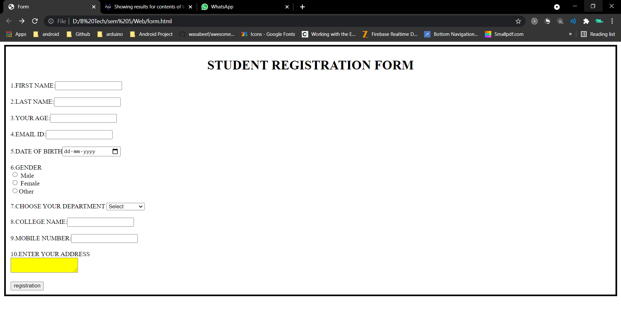

**1) First Name is Empty**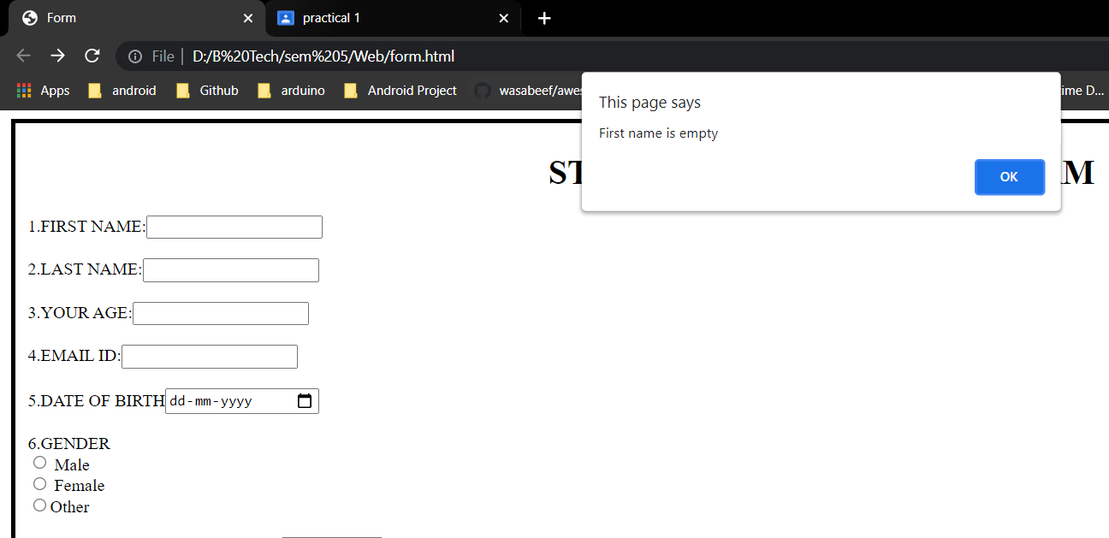

**2) First Name is Numbers not allowed!**

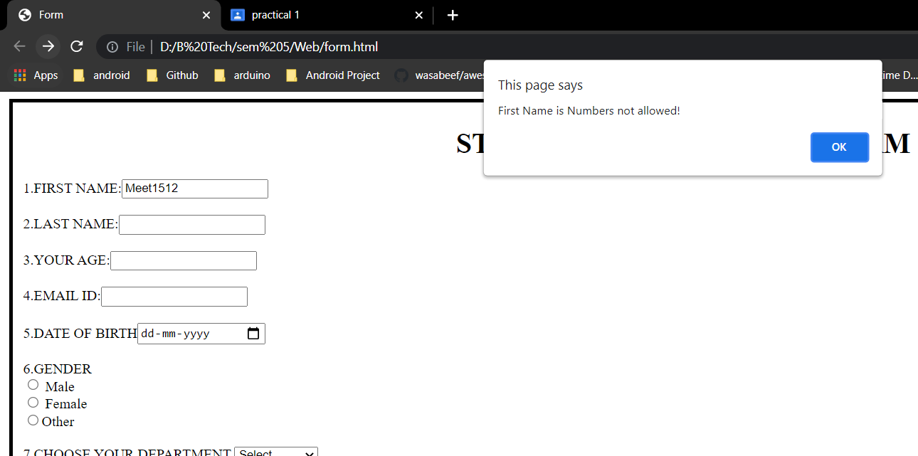

**3) Last name is empty**

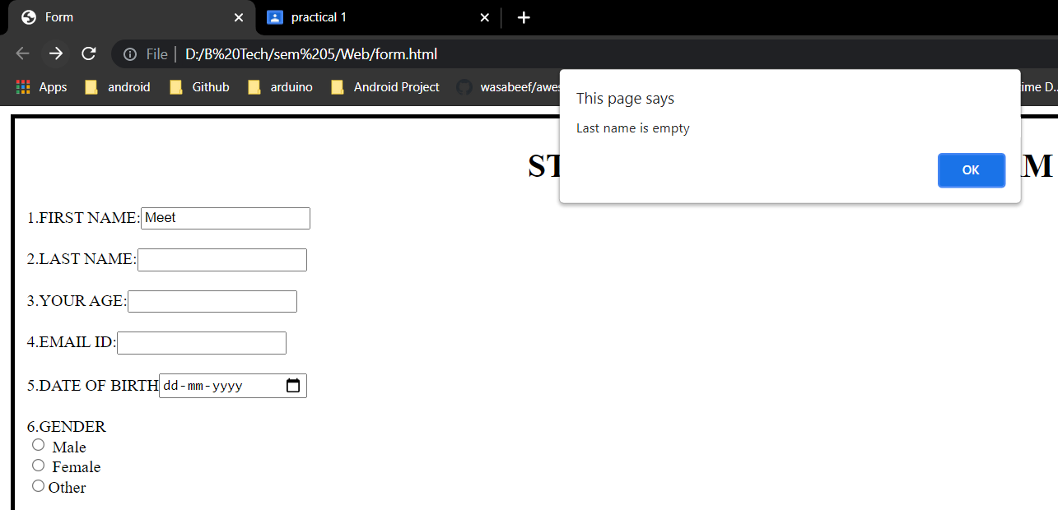

**4)** **Last Name is Numbers not allowed!**

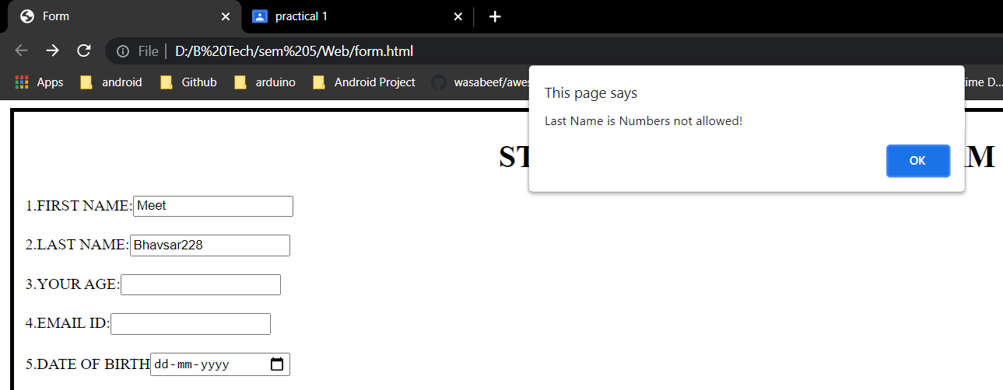

**5)** **Age must be only two digits and Age must be greater than 18**

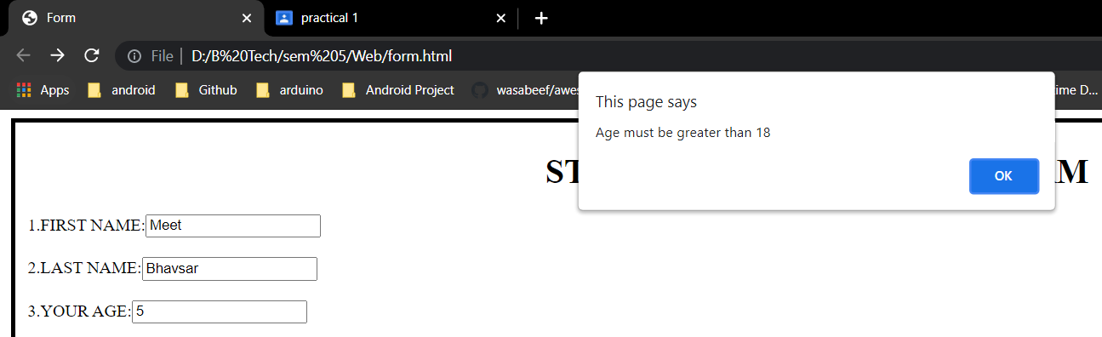

**6)** **Email is required**

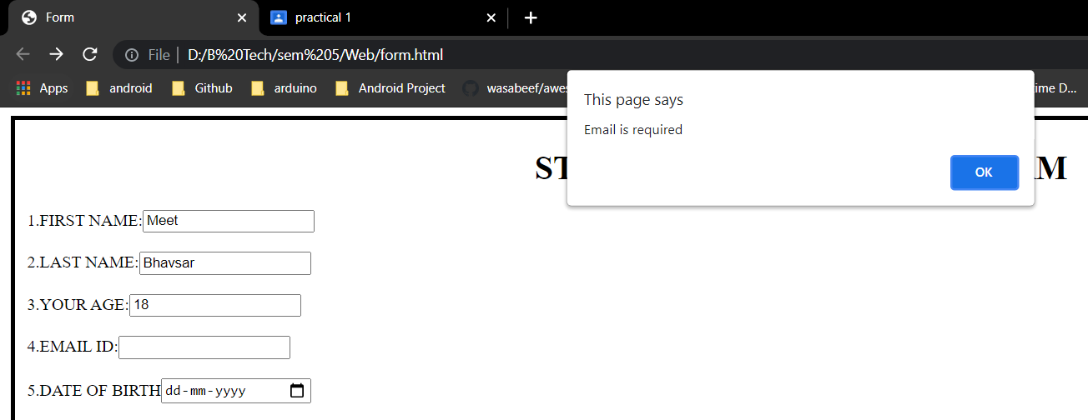

**7)** **Email id is not valid**

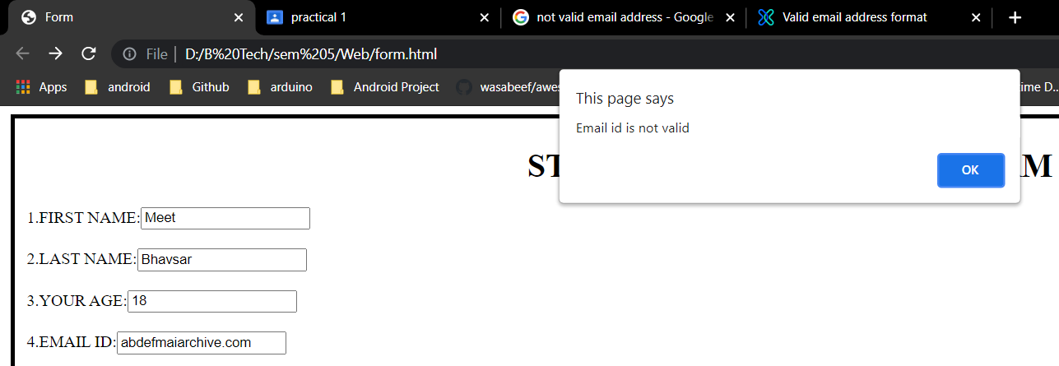

**8)** **Age does not match with the provided date**

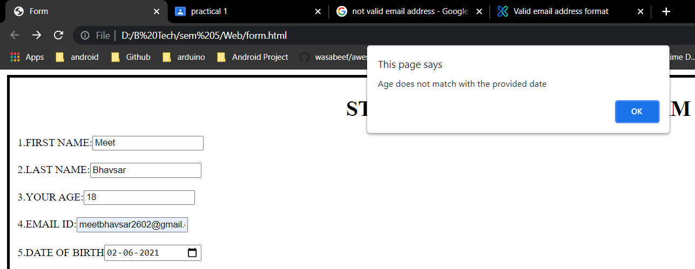

**9) Gender not selected**

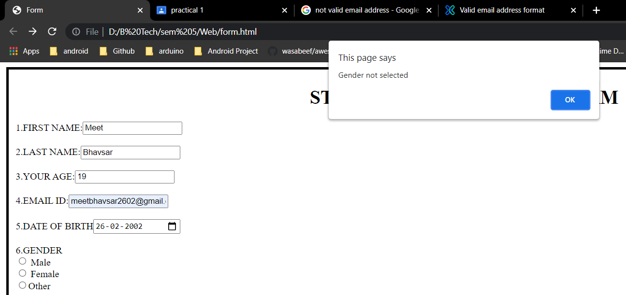

**10)** **Department not selected**

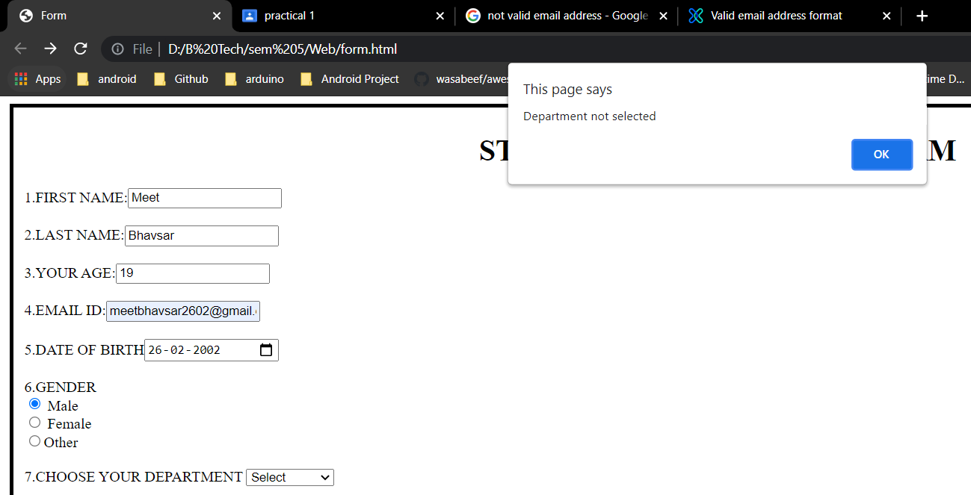

**11) College name is empty**

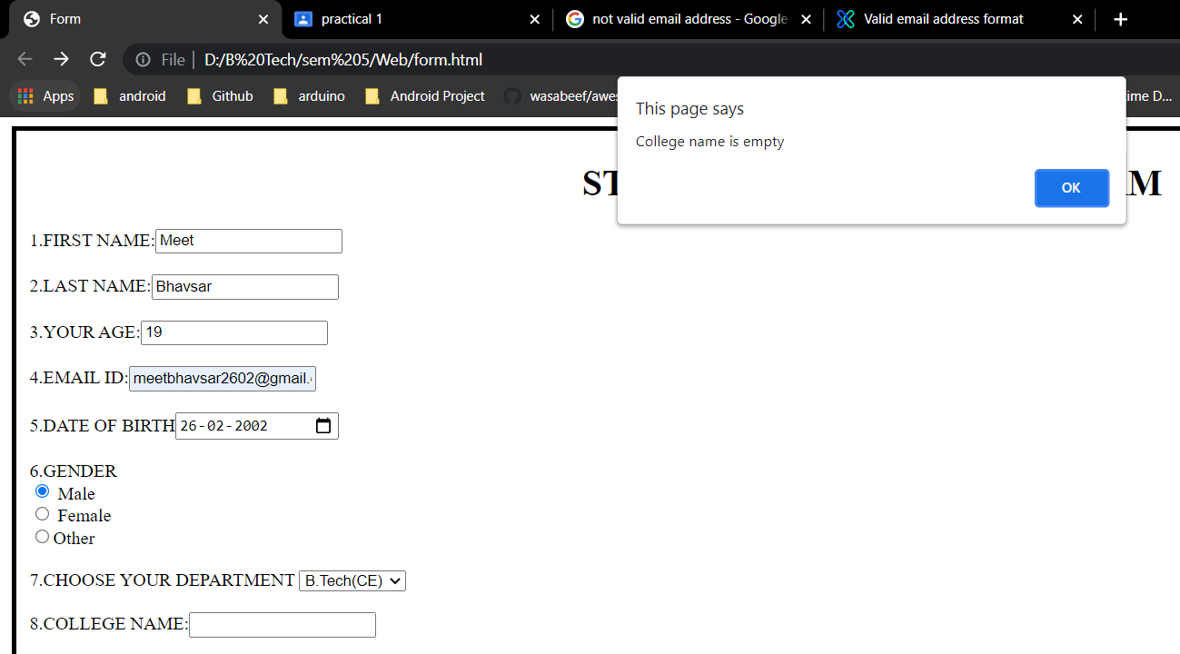

**12) College name should not contain only numbers**

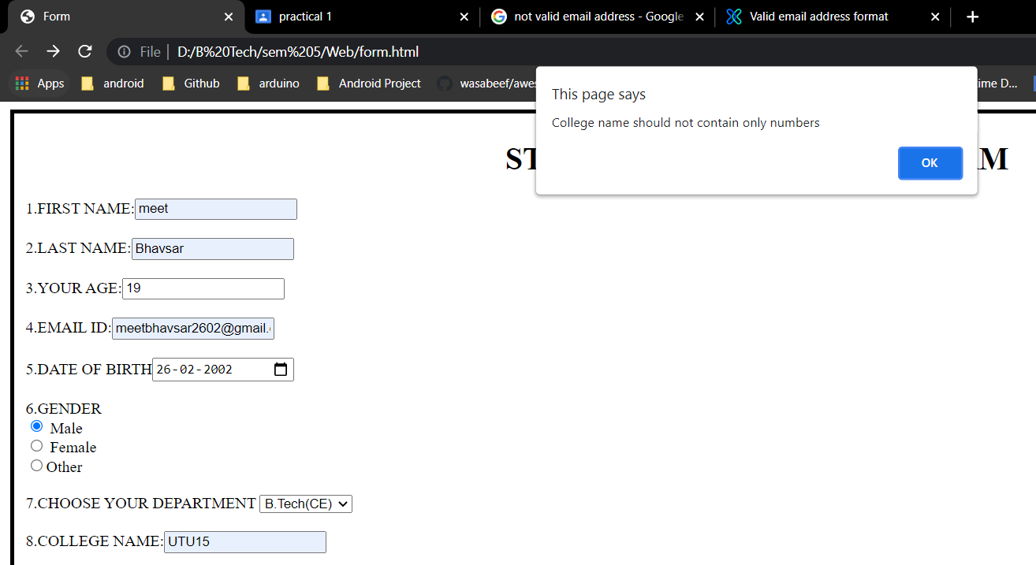

**13) Mobile number is required**

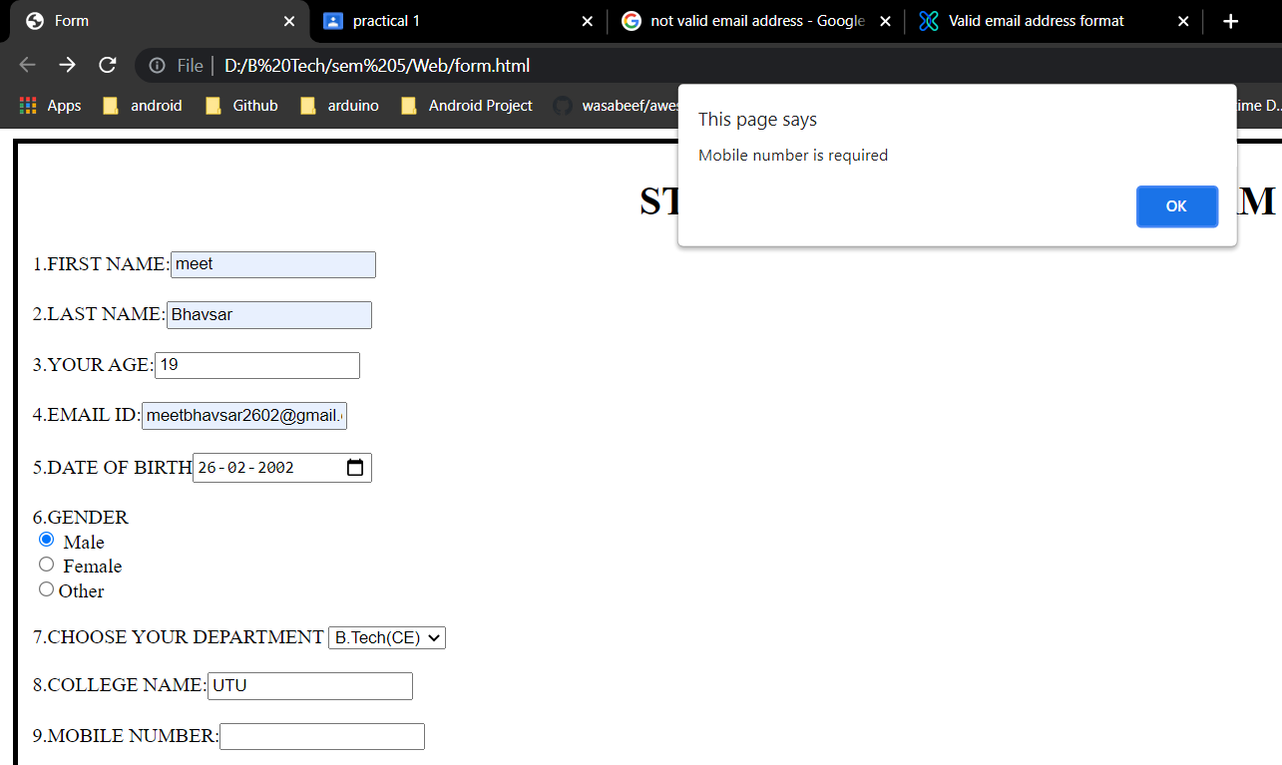

**14) Length of mobile number should be 10**

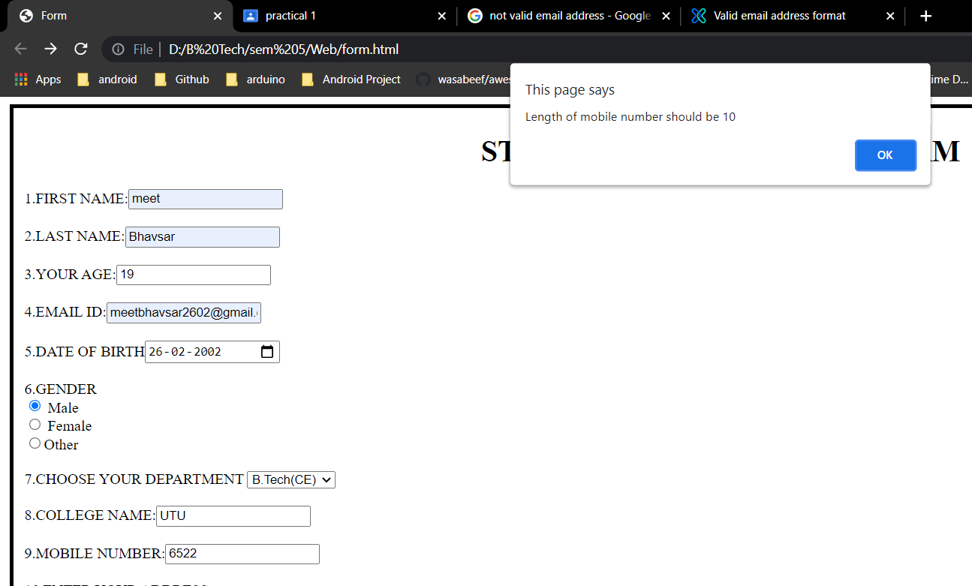

**15) Invalid mobile number**

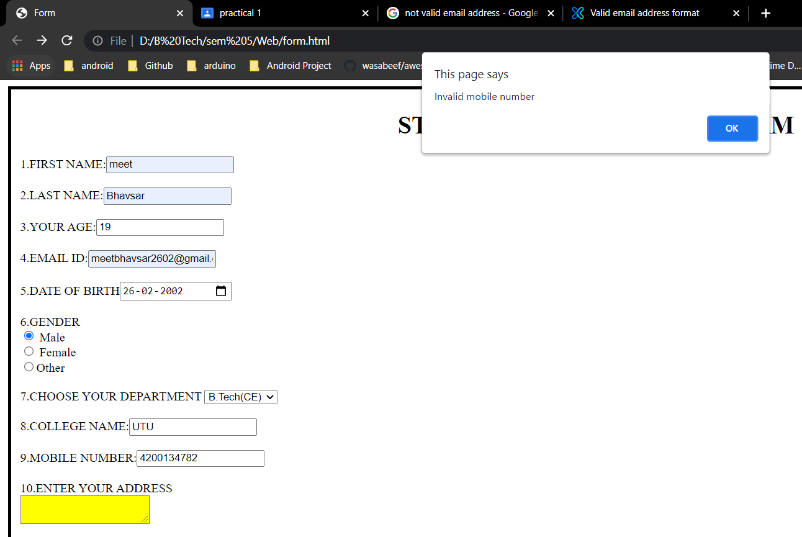

**16) Address is empty**

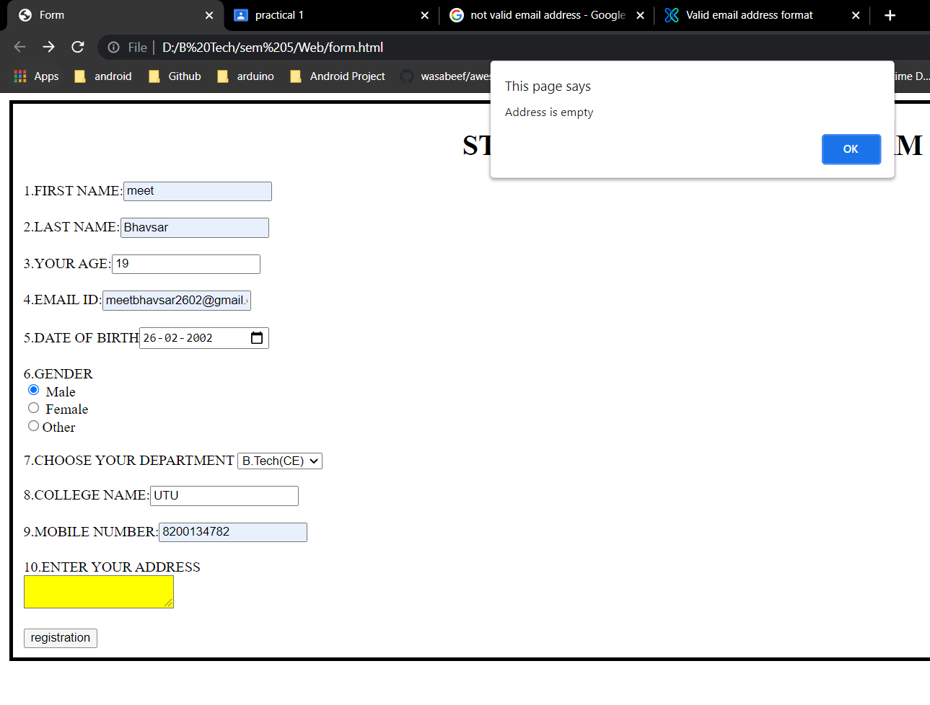

**Complete Validation:**

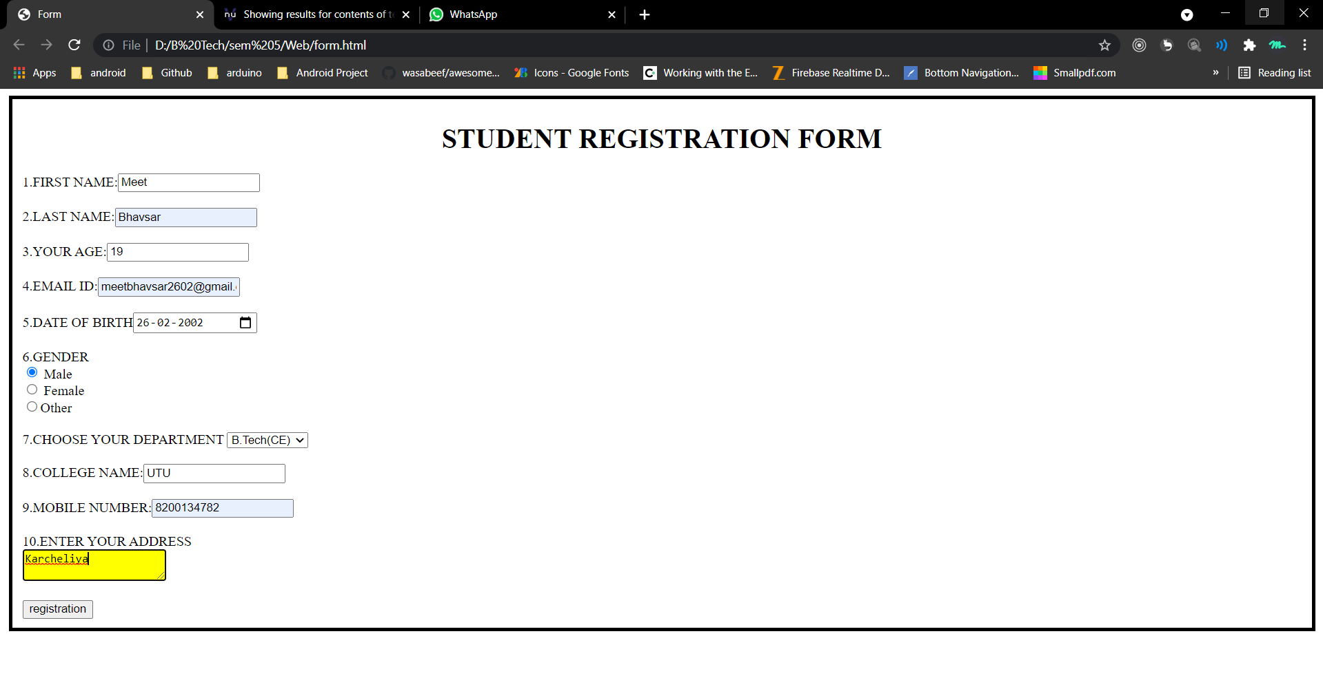

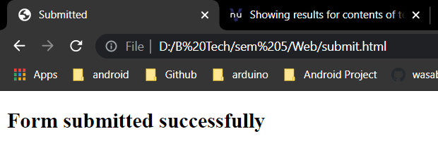

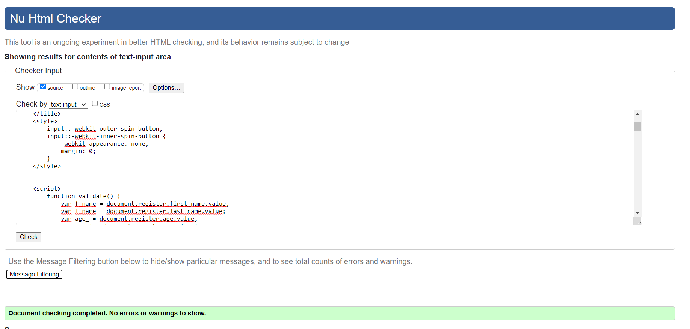

**Practical - 2**

**Aim:**

1. **Write a PHP program to display today’s date in dd-mm-yyyy format.**

**Code:**

**P2a.php:**

<?php

echo date('d/m/Y');

?>

**Output:**

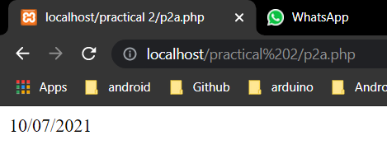

**b) Write a PHP program for swapping of two numbers.**

**Code:**

**P2b.php:**

<?php

$a = 10;

$b = 20;

echo "Before swapping: a=$a b=$b";

echo "<br>";

$temp = $a;

$a = $b;

$b = $temp;

echo "After swapping: a=$a b=$b";

?>

**Output:**

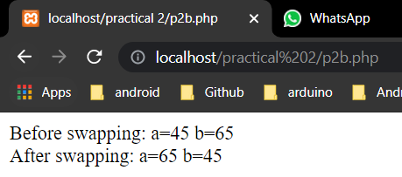

**c) Write a PHP program to print following pattern.**

**1**

**01**

**101**

**0101**

**10101**

**Code:**

**P2c.php:**

<?php

for($i=1; $i<=5; $i++){

for($j=$i; $j>=1; $j--){

echo $j % 2;

echo " ";

}

echo "<br>";

}

?>

**Output:**

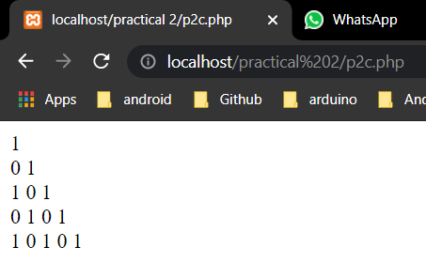

**d) Implement for-each loop to print username and password as key-value pair in PHP.**

**Code:**

**P2d.php:**

<?php

$arr = array("Meet"=>"meet2602","Rushil"=>"rushil123");

foreach($arr as $a=>$value){

echo "Username:$a <br> Password:$value <br>";

}

?>

**Output:**

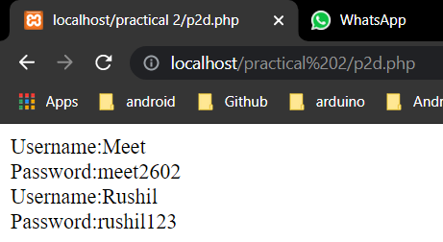

**PRACTICAL - 3**

**Aim: Write a PHP program to apply following string functions on data of file and save the result in the same file. strtolower(), strtoupper(), strlen(), ltrim(), rtrim(), trim(), substr(), strcmp(), strcasecmp(), strpos(), str_replace(), strrev().**

**1) strtolower():**

**Code:**

<?php

$str = "MEET";

echo strtolower($str);

?>

**Output:**

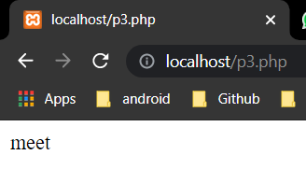

**2) strtoupper():**

**Code:**

<?php

$str = "meet";

echo strtoupper($str);

?>

**Output:**

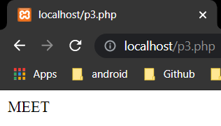

**3) strlen():**

**Code:**

<?php

$str = "Meet";

echo "Length of string:",strlen($str);

?>

**Output:**

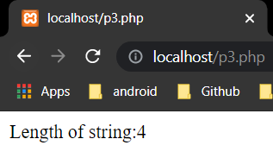

**4) ltrim():**

**Code:**

<?php

$str = "meet";

echo ltrim($str,"m");

?>

**Output:**

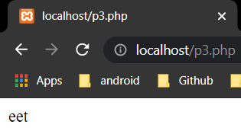

**5) rtrim():**

**Code:**

<?php

$str = "meet";

echo rtrim($str,"m");

?>

**Output:**

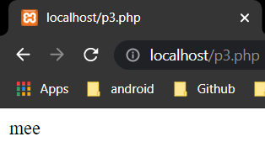

**6) trim():**

**Code:**

<?php

$str = "meet";

echo trim($str,"mt");

?>

**Output:**

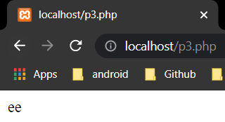

**7) substr():**

**Code:**

<?php

$str = "meetbhavsar";

echo substr($str,4);

?>

**Output:**

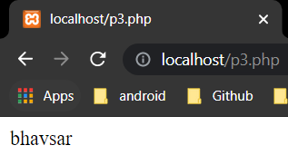

**8) strcmp():**

**Code:**

<?php

$str = "meet";

$str1 = "hello";

$str2 = "meet";

echo strcmp($str,$str1),"<br>";

echo strcmp($str1,$str2),"<br>";

echo strcmp($str,$str2),"<br>";

?>

**Output:**

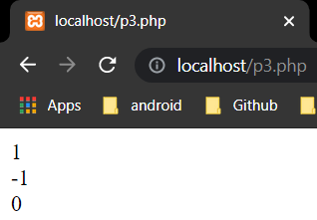

**9) strcasecmp():**

**Code:**

<?php

$str = "meet";

$str1 = "Meet";

echo strcasecmp($str1,$str);

?>

**Output:**

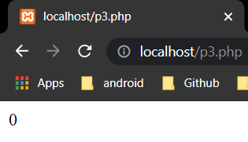

**10) strpos():**

**Code:**

<?php

$str = "meetbhavsar";

echo strpos($str,"b");

?>

**Output:**

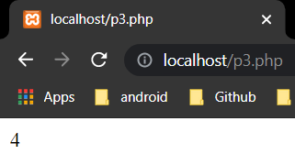

**11) str_replace():**

**Code:**

<?php

$str = "meetbhavsar";

echo str_replace("bhavsar","gamit",$str);

?>

**Output:**

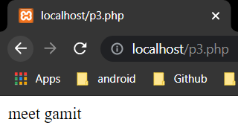

**12) strrev():**

**Code:**

<?php

$str = "meet bhavsar";

echo strrev($str);

?>

**Output:**

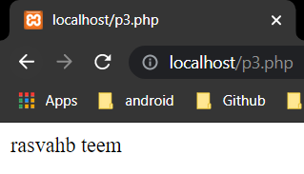

**Practical - 4**

**Aim: Write a PHP program for storing and retrieving user information**

**from MySQL table.**

**a. Design a HTML registration and login page which takes name, password, email and mobile number from user.**

**b. Store this data in MySQL database.**

**c. On next page display all user in HTML table using PHP.**

**d. Update/Delete details of user.**

**Code:**

**my_scipt.js:**

function validate() {

    var f_name = document.register.first_name.value;

    var l_name = document.register.last_name.value;

    var age_ = document.register.age.value;

    var email = document.register.email.value;

    var dob = document.register.dob.value;

    var gender = document.register.gender.value;

    var dept = document.register.dept.value;

    var college_name = document.register.college.value;

    var mobile_num = document.register.mobile.value;

    var address = document.register.address.value;

    if (f_name == "") {

        alert("First name is empty");

        return false;

    }

    if (/\d/.test(f_name)) {

        alert("First Name is Numbers not allowed!");

        return false;

    }

    if (l_name == "") {

        alert("Last name is empty");

        return false;

    }

    if (/\d/.test(l_name)) {

        alert("Last Name is Numbers not allowed!");

        return false;

    }

    if (age_.length > 2) {

        alert("Age must be only two digits");

        return false;

    }

    if (age_ < 18) {

        alert("Age must be greater than 18");

        return false;

    }

    if (email == "") {

        alert("Email is required");

        return false;

    }

    var mailformat = /^[a-zA-Z0-9.!#$%&'*+/=?^_`{|}~-]+@[a-zA-Z0-9-]+(?:\.[a-zA-Z0-9-]+)*$/;

    if (!email.match(mailformat)) {

        alert("Email id is not valid");

        return false;

    }

    var today = new Date();

    var birthDate = new Date(dob);

    var age = today.getFullYear() - birthDate.getFullYear();

    if (age != age_) {

        alert("Age does not match with the provided date");

        return false;

    }

    if (gender == "") {

        alert("Gender not selected");

        return false;

    }

    if (dept == "") {

        alert("Department not selected");

        return false;

    }

    if (college_name == "") {

        alert("College name is empty");

        return false;

    }

    if (/\d/.test(college_name)) {

        alert("College name should not contain only numbers");

        return false;

    }

    if (mobile_num == "") {

        alert("Mobile number is required");

        return false;

    }

    if (mobile_num.length != 10) {

        alert("Length of mobile number should be 10");

        return false;

    }

    if (!/^[6-9]/.test(mobile_num)) {

        alert("Invalid mobile number");

        return false;

    }

    if (address == "") {

        alert("Address is empty");

        return false;

    }

}

**config.php:**

<?php

define('DB_SERVER', 'localhost');

define('DB_USERNAME', 'root');

define('DB_PASSWORD', '');

define('DB_NAME', 'crud');

/* Attempt to connect to MySQL database */

$mysqli = new mysqli(DB_SERVER, DB_USERNAME, DB_PASSWORD, DB_NAME);

// Check connection

if($mysqli === false){

die("ERROR: Could not connect. " . $mysqli->connect_error);

}

?>

**create_table.php:**

<?php

    include_once("config.php");

    $sql = "CREATE TABLE register (

id INT(6) UNSIGNED AUTO_INCREMENT PRIMARY KEY,

first_name VARCHAR(30) NOT NULL,

last_name VARCHAR(30) NOT NULL,

age VARCHAR(30) NOT NULL,

email VARCHAR(30) NOT NULL,

dob VARCHAR(30) NOT NULL,

gender VARCHAR(30) NOT NULL,

dept VARCHAR(30) NOT NULL,

college VARCHAR(30) NOT NULL,

mobile VARCHAR(30) NOT NULL,

address VARCHAR(30) NOT NULL,

reg_date TIMESTAMP DEFAULT CURRENT_TIMESTAMP ON UPDATE CURRENT_TIMESTAMP

)";

    if (mysqli_query($mysqli, $sql)) {

        echo "Table Register created successfully";

    } else {

        echo "Error creating table: " . mysqli_error($mysqli);

    }

?>

**add_user.php:**

<!DOCTYPE html>

<html lang="en">

<head>

    <title>

        Form

    </title>

    <style>

        input::-webkit-outer-spin-button,

        input::-webkit-inner-spin-button {

            -webkit-appearance: none;

            margin: 0;

        }

    </style>

    <script src="./my_scipt.js">

    </script>

</head>

<body>

    <fieldset style="border:4px solid rgb(0, 0, 0);">

        <h1 style="text-align: center;">STUDENT REGISTRATION FORM</h1>

        <form name="register" method="POST" onsubmit="return validate()" action="add_user.php">

            1.FIRST NAME:<input type="text" name="first_name"><br><br>

            2.LAST NAME:<input type="text" name="last_name"><br><br>

            3.YOUR AGE:<input type="number" name="age"><br><br>

            4.EMAIL ID:<input type="email" name="email"><br><br>

            5.DATE OF BIRTH<input type="date" name="dob"><br><br>

            6.GENDER<br>

            <input type="radio" name="gender" value="male"> Male<br>

            <input type="radio" name="gender" value="female"> Female<br>

            <input type="radio" name="gender" value="other">Other<br><br>

            7.CHOOSE YOUR DEPARTMENT

            <select name="dept">

                <option value="">Select</option>

                <option value="CE">B.Tech(CE)</option>

                <option value="IT">B.Tech(IT)</option>

                <option value="EE">B.Tech(EE)</option>

                <option value="ME">B.Tech(ME)</option>

            </select><br><br>

            8.COLLEGE NAME:<input type="text" name="college"><br><br>

            9.MOBILE NUMBER:<input type="number" name="mobile"><br><br>

            10.ENTER YOUR ADDRESS<br><textarea name="address" style="background-color: yellow;"></textarea><br><br>

            <input type="submit" name="submit" value="registration">

        </form>

    </fieldset>

    <?php

    // Check If form submitted, insert form data into users table.

    if (isset($_POST['submit'])) {

        $f_name = $_POST['first_name'];

        $l_name = $_POST['last_name'];

        $age_ = $_POST['age'];

        $email = $_POST['email'];

        $dob = $_POST['dob'];

        $gender = $_POST['gender'];

        $dept = $_POST['dept'];

        $college_name = $_POST['college'];

        $mobile_num = $_POST['mobile'];

        $address = $_POST['address'];

        // include database connection file

        include_once("config.php");

        // Insert user data into table

        $sql = "INSERT INTO register (first_name,last_name,age,email,dob,gender,dept,college,mobile,address)

VALUES ('$f_name','$l_name','$age_','$email','$dob','$gender','$dept','$college_name','$mobile_num','$address')";

        if (mysqli_query($mysqli, $sql)) {

            // Show message when user added

            echo "User added successfully. <a href='view_user.php'>View Users</a>";

        } else {

            echo "Error: " . $sql . "<br>" . mysqli_error($mysqli);

        }

        mysqli_close($mysqli);

    }

    ?>

</body>

</html>

**view_user.php:**

<?php

// Create database connection using config file

include_once("config.php");

?>

<html>

<head>

    <title>Homepage</title>

</head>

<body>

    <a href="add_user.php">Add New User</a><br /><br />

    <?php

    $sql = "SELECT * FROM register ORDER BY id ASC";

    $result = mysqli_query($mysqli, $sql);

    if (mysqli_num_rows($result) > 0) { ?>

        <table width='80%' border=1>

            <tr>

                <th>id </th>

                <th>first_name</th>

                <th>last_name</th>

                <th>age</th>

                <th>email</th>

                <th>dob</th>

                <th>gender</th>

                <th>dept</th>

                <th>college</th>

                <th>mobile</th>

                <th>address</th>

                <th></th>

            </tr>

        <?php

        // Fetch all users data from datsabase

        while ($user_data = mysqli_fetch_array($result)) {

            echo "<tr>";

            echo "<td>" . $user_data['id'] . "</td>";

            echo "<td>" . $user_data['first_name'] . "</td>";

            echo "<td>" . $user_data['last_name'] . "</td>";

            echo "<td>" . $user_data['age'] . "</td>";

            echo "<td>" . $user_data['email'] . "</td>";

            echo "<td>" . $user_data['dob'] . "</td>";

            echo "<td>" . $user_data['gender'] . "</td>";

            echo "<td>" . $user_data['dept'] . "</td>";

            echo "<td>" . $user_data['college'] . "</td>";

            echo "<td>" . $user_data['mobile'] . "</td>";

            echo "<td>" . $user_data['address'] . "</td>";

            echo "<td><a href='edit_user.php?id=$user_data[id]'>Edit</a> | <a href='delete_user.php?id=$user_data[id]'>Delete</a></td></tr>";

        }

    }

        ?>

        </table></body></html>

**delete_user.php:**

<?php

// Create database connection using config file

include_once("config.php");

$id = $_GET['id'];

// Delete user row from table based on given id

$result = mysqli_query($mysqli, "DELETE FROM register WHERE id=$id");

// After delete redirect to Home, so that latest user list will be displayed.

header("Location:view_user.php");

?>

**edit_user.php:**

<?php

// Check If form submitted, insert form data into users table.

include_once("config.php");

if (isset($_POST['update'])) {

    $id = $_POST['id'];

    $f_name = $_POST['first_name'];

    $l_name = $_POST['last_name'];

    $age_ = $_POST['age'];

    $email = $_POST['email'];

    $dob = $_POST['dob'];

    $gender = $_POST['gender'];

    $dept = $_POST['dept'];

    $college_name = $_POST['college'];

    $mobile_num = $_POST['mobile'];

    $address = $_POST['address'];

    // Update user data into table

    $sql = "UPDATE register SET first_name='$f_name',last_name='$l_name',age='$age_',email='$email',dob='$dob',gender='$gender',dept='$dept',college='$college_name',mobile='$mobile_num',address='$address' WHERE id=$id";

    $result = mysqli_query($mysqli, $sql);

    mysqli_close($mysqli);

    header("Location: view_user.php");

}

?>

<?php

// Display selected user data based on id

// Getting id from url

$id = $_GET['id'];

// Fetech user data based on id

$result = mysqli_query($mysqli, "SELECT * FROM register WHERE id=$id");

while ($user_data = mysqli_fetch_array($result)) {

    $first_name = $user_data['first_name'];

    $last_name = $user_data['last_name'];

    $age = $user_data['age'];

    $email = $user_data['email'];

    $dob = $user_data['dob'];

    $gender = $user_data['gender'];

    $dept = $user_data['dept'];

    $college = $user_data['college'];

    $mobile = $user_data['mobile'];

    $address = $user_data['address'];

}

?>

<!DOCTYPE html>

<html lang="en">

<head>

    <title>

        Form

    </title>

    <style>

        input::-webkit-outer-spin-button,

        input::-webkit-inner-spin-button {

            -webkit-appearance: none;

            margin: 0;

        }

    </style>

    <script src="./my_scipt.js">

    </script>

</head>

<body>

    <fieldset style="border:4px solid rgb(0, 0, 0);">

        <h1 style="text-align: center;">STUDENT REGISTRATION FORM</h1>

        <form name="register" method="POST" onsubmit="return validate()" action="edit_user.php">

            1.FIRST NAME:<input type="text" name="first_name" value=<?php echo $first_name; ?>><br><br>

            2.LAST NAME:<input type="text" name="last_name" value=<?php echo $last_name; ?>><br><br>

            3.YOUR AGE:<input type="number" name="age" value=<?php echo $age; ?>><br><br>

            4.EMAIL ID:<input type="email" name="email" value=<?php echo $email; ?>><br><br>

            5.DATE OF BIRTH<input type="date" name="dob" value=<?php echo $dob; ?>><br><br>

            6.GENDER<br>

            <input type="radio" name="gender" value="male" <?php if ($gender == "male") {

                                                                echo "checked";

                                                            } ?>> Male<br>

            <input type="radio" name="gender" value="female" <?php if ($gender == "female") {

                                                                    echo "checked";

                                                                } ?>> Female<br>

            <input type="radio" name="gender" value="other" <?php if ($gender == "other") {

                                                                echo "checked";

                                                            } ?>>Other<br><br>

            7.CHOOSE YOUR DEPARTMENT

            <select name="dept">

                <option value="">Select</option>

                <option value="CE" <?php if ($dept == 'CE') { ?> selected="selected" <?php } ?>>B.Tech(CE)</option>

                <option value="IT" <?php if ($dept == 'IT') { ?> selected="selected" <?php } ?>>B.Tech(IT)</option>

                <option value="EE" <?php if ($dept == 'EE') { ?> selected="selected" <?php } ?>>B.Tech(EE)</option>

                <option value="ME" <?php if ($dept == 'ME') { ?> selected="selected" <?php } ?>>B.Tech(ME)</option>

            </select><br><br>

            8.COLLEGE NAME:<input type="text" name="college" value=<?php echo $college; ?>><br><br>

            9.MOBILE NUMBER:<input type="number" name="mobile" value=<?php echo $mobile; ?>><br><br>

            10.ENTER YOUR ADDRESS<br><textarea name="address" style="background-color: yellow;"><?php echo htmlspecialchars($address); ?></textarea><br><br>

            <input type="hidden" name="id" value=<?php echo $_GET['id']; ?>></td>

            <input type="submit" name="update" value="Update User">

        </form>

    </fieldset>

</body>

</html>

**Output:**

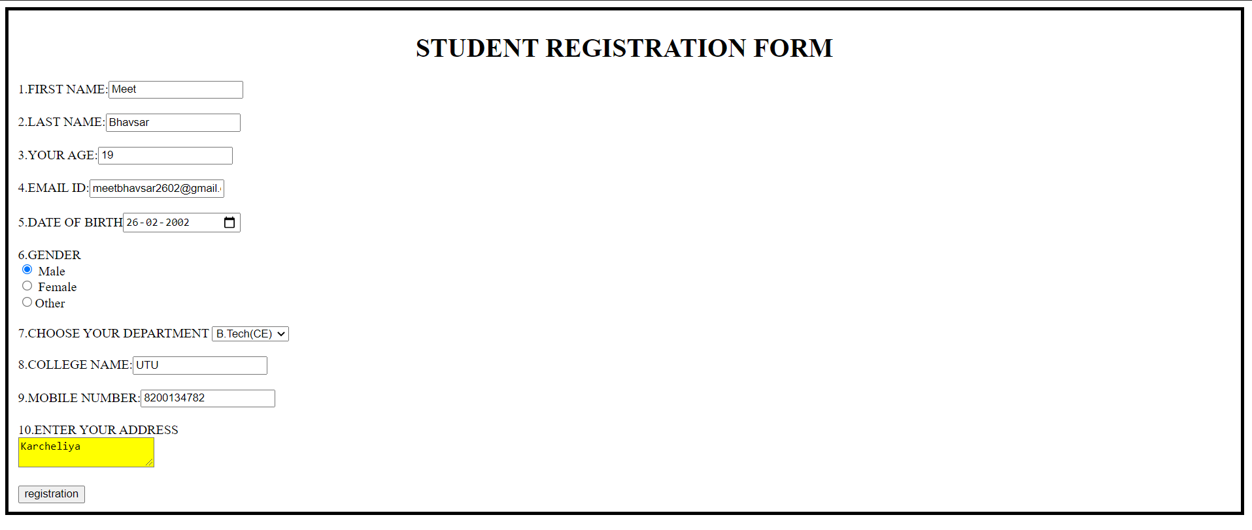

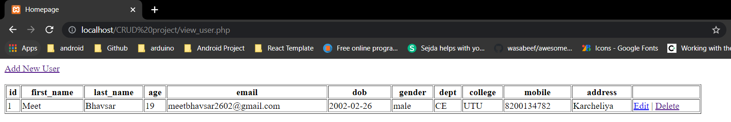

**Practical - 5**

**Aim: Implement session and cookie to maintain session during login and implement visitor counter.**

**Code:**

**form.php:**

<?php

session_start();

?>

<html>

<head>

</head>

<body>

    <form name="login_form" method="POST">

        Email:<input type='email' name='login'><br>

        <input type='submit' name='submit' value='Submit'>

    </form>

    <?php

    if ($_SERVER["REQUEST_METHOD"] == "POST") {

        $_SESSION["login_id"] = $_POST['login'];

        header("location:index.php");

    }

    ?>

</body>

</html>

**index.php:**

<?php

session_start();

if (isset($_SESSION['count'])) {

    $_SESSION['count'] = $_SESSION['count'] + 1;

} else {

    $_SESSION['count'] = 1;

}

?>

<html>

<body>

    <?php

    if (isset($_SESSION['login_id'])) {

        $id = $_SESSION["login_id"];

        echo "Email ";

        echo $id;

        $count = $_SESSION['count'];

        echo "<h2>You have visited this page $count times in this session</h2>";

        echo "<br><a href=" . "logout.php" . ">Logout</a>";

    } else {

        echo "Please login<br>";

        echo "<a href=" . "form.php" . ">Login</a>";

    }

    ?>

</body>

</html>

**logout.php:**

<?php

session_start();

if (isset($_SESSION['login_id'])) {

$id = $_SESSION["login_id"];

    unset($_SESSION['count']);

    session_destroy();

    echo "Session destroyed";

}else{

    echo "Please login<br>";

    echo "<a href=" . "form.php" . ">Login</a>";

}

?>

**Output:**

